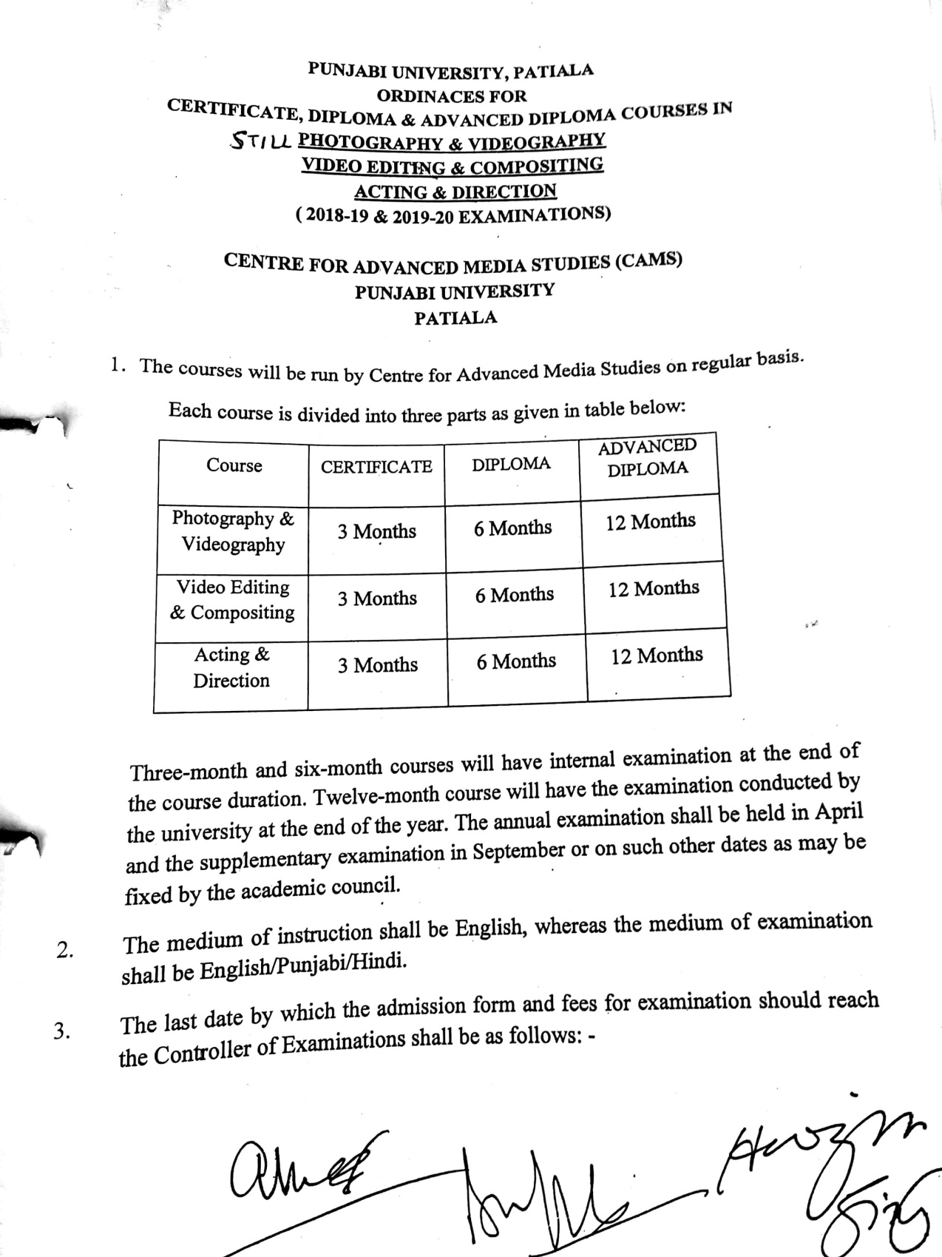

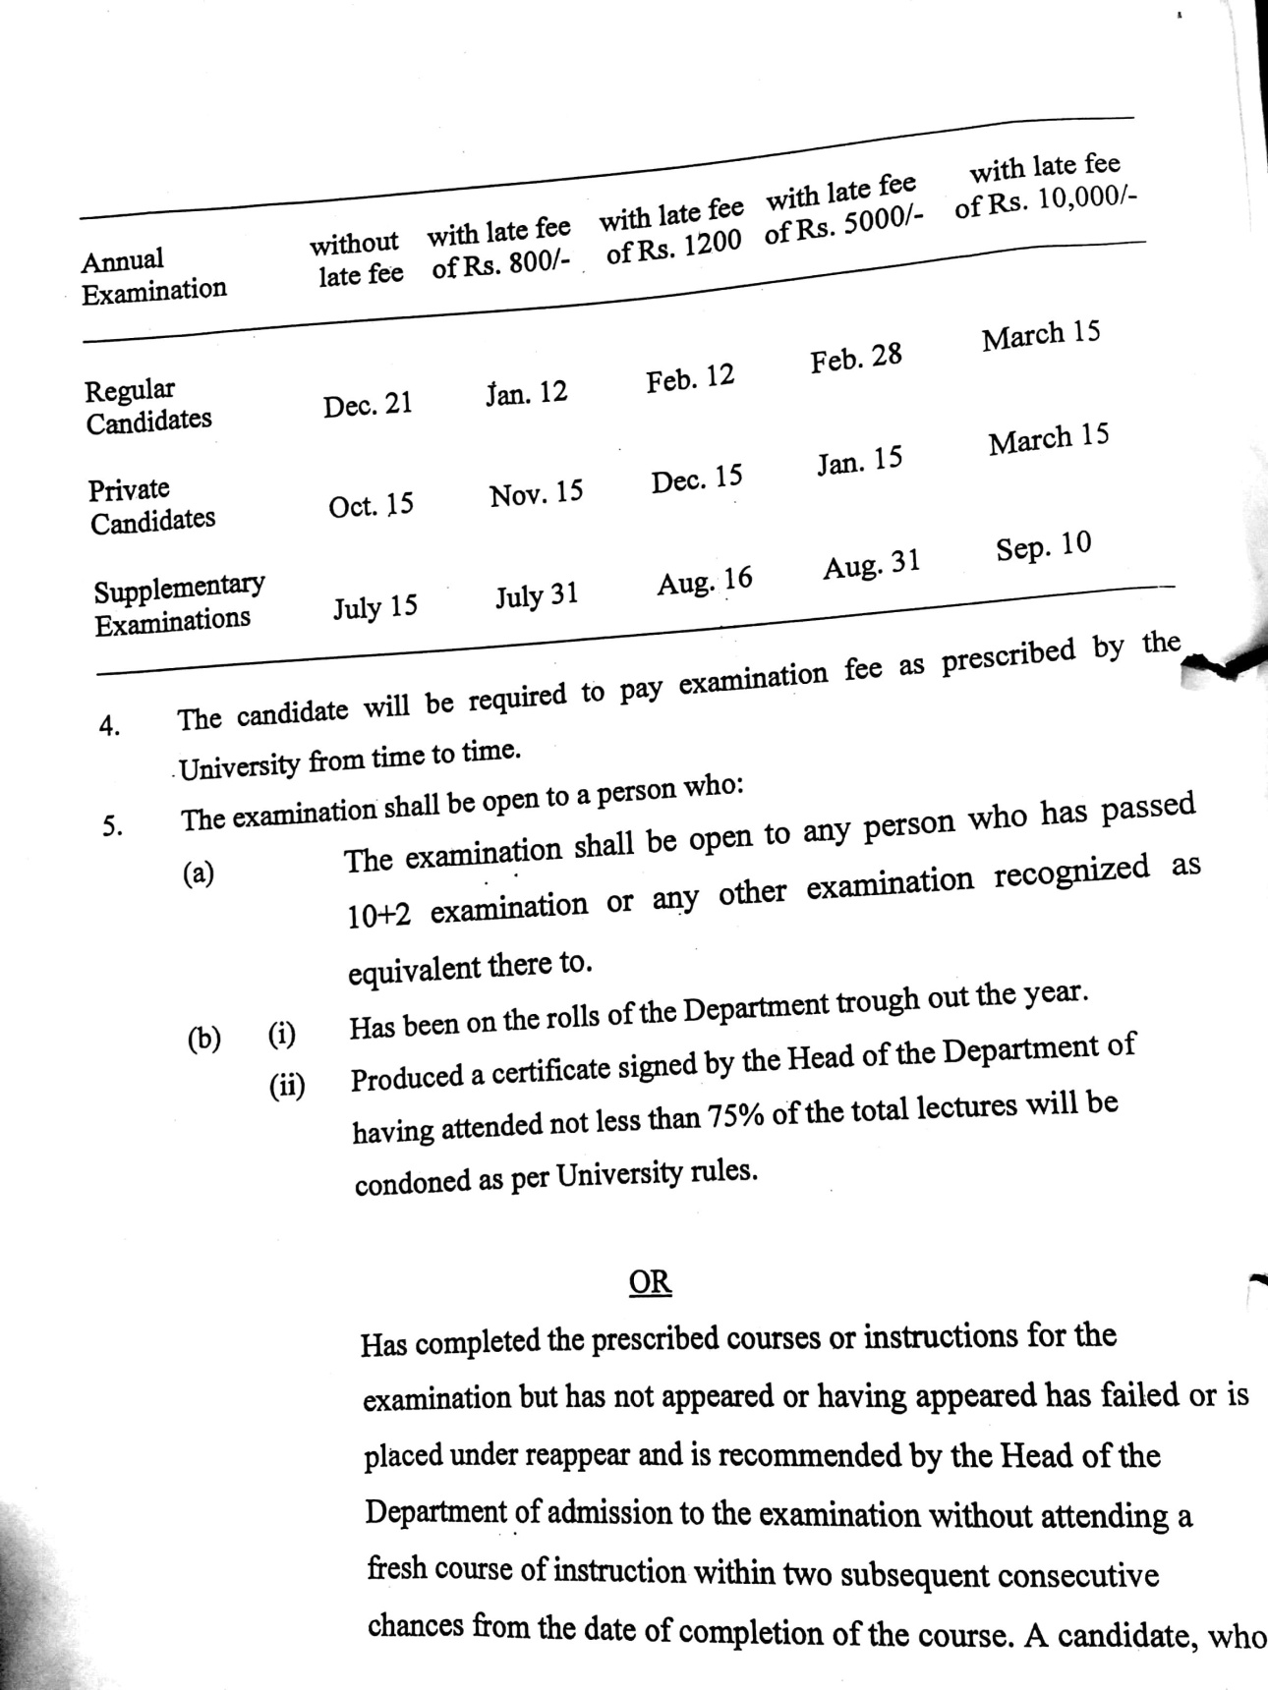

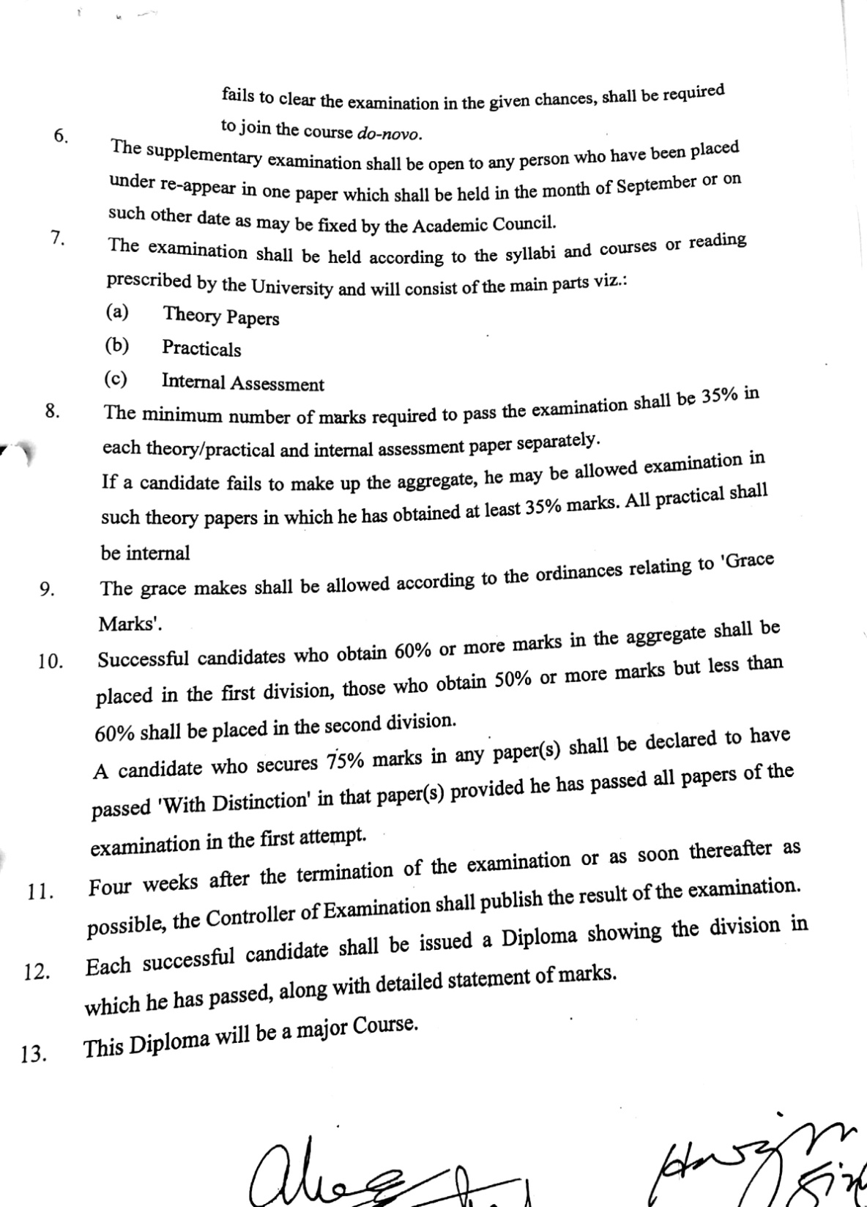

SYLLABUS

Short Term Evening Courses
SESSION: 2018–2019, 2019-2020&
2020-2021
STILL PHOTOGRAPHY AND VIDEOGRAPHY

PAPER-Photography & Videography (3Months)

PAPER-Photography & Videography(6Months)

PAPER-Photography & Videography(one year)

PAPER-Photography & Videography (3Months)

Max. Marks: 100 Continuous Internal Evaluation 80 Marks
Pass Marks: 35 Internal Assessment 20 Marks

INSTRUCTIONS FOR THE CANDIDATES

Candidates will be required to submit assignments from each section and perform the tasks given by the teacher(s) during the entire period of the three months. Evaluation will be done on the basis of quality of assignments and viva voce. Each section will carry 10 marks.

Course Content
SECTION A
Amateur and professional photography: Differences in approach, How photographs are read, Markets for professional photography, Roles within a photographic business, Turning professional; Camera equipment: Camera design, Image format, The digital revolution, Digital camera equipment, Image sensors; Choosing Lenses: Prime, Telephoto, Wide, Normal, Zoom, Lens Distortions; Camera parameters: Focal length, Aperture, Shutter speed, ISO, Depth of field; Basics of composition: Rule of thirds, Understanding lines: - Straight, horizontal, converging, diagonal and curved; Subjects: Sport and action, Photo-journalism/documentary, Portraiture, Weddings, Landscapes, Architecture, Built studio sets, Studio still-lifes, Natural history, Aerial subjects, Night skies.
SECTION B
Video: What is a video, Illusion of movement, persistence of vision; Structure of camera: CCD, CMOS, 3CCD structure, video data storage; Scanning: PAL, NTSC, Progressive and interlaced scanning; Aspect ratio: SD, HD, 2K, 4K; Parameters of camera: Focal length, Aperture, shutter speed, DOF, white balance, black balance, zebra; Lenses: Prime, zoom, telephoto, wide, normal; Types of shots: extreme long shot, long shot, medium shot, extreme close up, close up, over the shoulder shot, two shot, three shot, group shot; Framing: Safety margins, looking room, head room.

Text and References
- Langford's Basic Photography - The Guide for Serious Photographers 9th Ed - 2010
- Focal.Press.Langfords.Starting.Photography.5th.Edition.Feb.2007
- Fundamentals of Television Production: Donald, Ralph & Spann, T
- Editing Today: Smith, Ron F. & O'Connell, L.M, Blackwell Publishing
- Television Production Handbook: Zettl, Herbert Published 2005, Thomson Wadsworth

PAPER-Photography & Videography(6Months)

Max. Marks: 100 Continuous Internal Evaluation 80 Marks
Pass Marks: 35 Internal Assessment 20 Marks

INSTRUCTIONS FOR THE CANDIDATES

Candidates will be required to submit assignments from each section and perform the tasks given by the teacher(s) during the entire period of the three months. Evaluation will be done on the basis of quality of assignments and viva voce. Each section will carry 10 marks.

Course Content
Section A
Define Photography: Why photography? How photography works Picture structuring ,The roles photographs play ,Changing attitudes towards photography, Personal styles and approaches. Lighting: Light itself, Wavelengths and colors, Shadows, When light reaches a surface Light intensity and distance ,Making light form images. Lenses: Photographic lenses, Aperture and f-numbers, Depth of field , How depth of field works, Depth of focus, Image stabilization, Lenses for digital cameras. Exposure measurement: Aperture, Factors that determine what exposure to give. Using different focal length: Why change focal length? ,Lens kits, Close-up equipment, Essentials and extras ,Right for the job . Digital cameras: How are digital images captured? ,File formats Digital cameras. Lighting: principles and equipment: Basic characteristics of lighting, Lighting equipment , Practical lighting problems, Special subjects. Organizing the picture: Noticing subject features, Structuring pictures through the camera, Where photographs go.
Section B
Guidelines for Composition: Rule of thirds, 30-degree rule, line of imagination, inserts, cutaways; Camera Placement: Objective and subjective camera, POV shot, camera angles; Camera movement: Motivation for camera movement, the panning shot, the tilt shot the tracking shot, the circular move, the zoom in & out shot, the crane shot, the handheld shot, the steadicam shot, the ariel shot, static shot & moving the camera successfully i.e. Motion control; Types of cuts: content cut, action cut, POV cut, match cut, zero cut, concept cut; Shooting methods: Master shot method, building floor map, line script, shooting script; Mounting devices: Shoulder mount, monopod, tripod, steadicam, helicam, pedestals, jibs, ronins, bean bags, high hat etc. Text and References

- Langford's Basic Photography - The Guide for Serious Photographers 9th Ed - 2010
- Focal.Press.Langfords.Starting.Photography.5th.Edition.Feb.2007
- Fundamentals of Television Production: Donald, Ralph & Spann, T
- Television Production Handbook: Zettl, Herbert Published 2005, Thomson Wadsworth

PAPER-Photography & Videography(one year)

Max. Marks: 100 Theory: 60 Marks
Pass Marks: 35 Practical: 20 Marks
Time Allowed: 3 Hours Internal Assessment: 20 Marks

INSTRUCTIONS FOR THE PAPER-SETTER
The question paper will consist of three sections: A, B and C. Sections A and B will have four questions from the respective sections of the syllabus and will carry 10 marks each. Section C will consist of 10 short-answer type questions which will cover the entire syllabus uniformly and will carry 20 marks in all.

INSTRUCTIONS FOR THE CANDIDATES
Candidates are required to attempt two question each from the sections A and B of the question paper and the entire section C.

Course Content
Section A
Picture Making :Seeing and photographing ,Using the viewfinder – framing up ,Creating a point of emphasis ,Picking lighting conditions ,Pattern, texture and shape ,Using color. Camera, Sensors and Film: Camera, Sensors and Film, Camera principles, The camera, Sensors , Films , Scanners. Creative Use of Camera Controls: Creative Use of Camera Controls , Shutter speeds and movement, Focus and aperture, Choice of exposure, Changing focal length. Photographic Subjects: People , Places , Animal portraits, Landscapes ,Close-up subjects ,Action and sports photographs. Controlling Light: Lighting for people photographs, Lighting objects, Outside shooting Flash and its control ,Layout and lighting in the studio. Experimental and Constructed Images: Letting the image move, Exploring reflections Using lens attachments, Combining pictures, Creative digital.
Section B
Introduction to Visual Storytelling: Visual storytelling, Factors that make visuals powerful (Cultural relevancy, authenticity, archetypal characters, nostalgia etc.) Images as communication: Image analysis through different perspective (Personal, historical, technical, ethical, cultural and critical); Composition: stimulating the imaginative involvement, the arrangement of compositional elements (horizontally, vertically, s-shaped & diagonally), the frame and the three axis, closed and open frames, deep and shallow frames, balanced and unbalanced frames, sound as an element of composition; Fundamentals of lighting.
Text and References
- Langford's Basic Photography - The Guide for Serious Photographers 9th Ed - 2010
- Writing and Producing Television News: Gormly, Eric K, Ames, Iowa: Blackwell Publishing
- Fundamentals of Television Production: Donald, Ralph & Spann,
- Langford's Advanced Photography (The Langford Series) 8th Edition
- Langford's Basic Photography - The Guide for Serious Photographers 9th Ed - 2010
- Focal.Press.Langfords.Starting.Photography.5th.Edition.Feb.2007
- Television Production Handbook: Zettl, Herbert Published 2005, Thomson Wadsworth

